Average Effect Sizes in
Developer-Commissioned and Independent Evaluations

Abstract
Rigorous evidence of program effectiveness has become increasingly important with the 2015 passage of the Every Student Succeeds Act (ESSA). One question that has not yet been fully explored is whether program evaluations carried out or commissioned by developers produce larger effect sizes than evaluations conducted by independent third parties. Using study data from the What Works Clearinghouse, we find evidence of a “developer effect,” where program evaluations carried out or commissioned by developers produced average effect sizes that were substantially larger than those identified in evaluations conducted by independent parties. We explore potential reasons for the existence of a “developer effect” and provide evidence that interventions evaluated by developers were not simply more effective than those evaluated by independent parties. We conclude by discussing plausible explanations for this phenomenon as well as providing suggestions for researchers to mitigate potential bias in evaluations moving forward.
Introduction
While researchers have advocated for the use of rigorous evidence in educational decision-making for many years, policymakers have recently mandated the use of evidence in selecting educational programs. The Every Student Succeeds Act (ESSA) of 2015 requires that schools seeking certain types of educational funding from the federal government select programs supported by evidence, and encourages use of evidence more broadly. Specifically, ESSA evidence standards require that low-achieving schools seeking school improvement funding select programs that have at least one rigorous study showing statistically significant positive effects (and no studies showing negative effects). For a “strong” rating the study must use a randomized design, for “moderate” a matched or quasi-experimental design, and for “promising” a correlational design with statistical controls for selection bias. In some programs beyond school improvement, applicants for federal grants can receive bonus points if they propose to use programs meeting these ESSA evidence standards. Some states are applying similar standards for certain state funding initiatives (Klein, 2018).
One challenge practitioners face is identifying educational programs that are supported by evidence that meets ESSA standards. Some have suggested that evidence that meets ESSA standards could be determined according to whether the evidence meets the rigorous standards of the What Works Clearinghouse (WWC) (Lester, 2018). The Institute of Education Sciences (IES) within the U.S. Department of Education established the WWC in 2002 to provide the education community with a “central and trusted source of scientific evidence of what works in education” (WWC, 2017a, p. 1). Expert individuals and organizations contracted by IES identify, review, and rate studies of educational programs for the WWC. Ratings of specific educational programs may be accessed via the WWC website, https://ies.ed.gov/ncee/wwc/.
Whether practitioners use evidence from the WWC or elsewhere, one question that is worth exploring is whether the ESSA study ratings provide reliable evidence regarding the potential effectiveness of an intervention. Can practitioners rely on ESSA study ratings to make the most informed decisions about which educational programs to invest in for their students? Or do practitioners need additional knowledge to help them make the best investments for their students?
One question educators might ask is whether studies carried out or commissioned by developers produce larger effect sizes than studies carried out and funded by independent third parties. This question is particularly relevant since the passage of ESSA because developers now have a larger stake than they previously did in demonstrating evidence of their products. Developer-commissioned evaluations may be associated with higher effect sizes if they tend to use study design features known to inflate effect sizes, such as smaller sample sizes or researcher- or developer-made measures (see Cheung & Slavin, 2016). Alternatively, developer-commissioned studies with lackluster results may be withheld to a greater extent than those of independent parties, resulting in more bias due to a “file drawer effect” (Polanin, Tanner-Smith, & Hennessy, 2016; Sterling, Rosenbaum, & Weinkam, 1995). Publication bias likely exists for studies by independent parties too, given the pressure to publish for researchers at academic institutions and the preference of journals to publish a “compelling, ‘clean’ story” (John, Loewenstein, & Prelec, 2012; McBee, Makel, Peters, & Matthews, 2017, p. 6). However, developers may be further disincentivized to disseminate studies with negative or null findings about the efficacy of their products. Even if developers hire independent evaluators, evaluators may also be disincentivized from disseminating null or negative findings due to the low probability that the work will be published, and their desire to please their developer client and ultimately obtain future contracts and clients.
Another way that developers could potentially influence study results, either in studies they conduct internally or fund with independent evaluators, is by influencing study design and data cleaning and analysis decisions to produce the most favorable study results possible (Simmons, Nelson, & Simonsohn, 2011). Simmons et al. (2011) referred to these decisions about sample selection, variable selection (dependent and independent), and case exclusion (e.g., outliers) as “researcher degrees of freedom.” John, Loewenstein, and Prelec (2012), for example, surveyed 2,000 psychologists, of whom 63% admitted to not reporting all dependent variables in their disseminated studies. It is therefore conceivable that there may be a developer effect, at least to the extent that developer-commissioned studies make use of study design features that may inflate effect sizes, the file drawer, or researcher degrees of freedom to optimize study results.
Policies of the U.S. Department of Education (USDoE) applied to several major funding initiatives require use of independent, third-party evaluators. This is true of Investing in Innovation, top goal levels of the Institute for Education Sciences Striving Readers, and Preschool Curriculum Education Research. If the USDoE insists on third-party evaluators independent of program developers, then they must believe that there is potential for bias in studies conducted by the developers themselves. However, this safeguard may not prevent all potential bias in studies commissioned by developers.
The purpose of this article is to determine whether studies commissioned or carried out by developers reported effect sizes that were systematically larger than those in studies carried out by independent researchers. If there is a difference, we will explore why: Are there observed features of developer-commissioned evaluations that explain any systematic differences in effect sizes? Or, could it be the case that interventions evaluated in developer-commissioned evaluations were simply more effective than interventions studied by independent parties? This article uses data from the WWC database of study findings, and other information from individual studies, to explore these questions and determine how developer-commissioned research relates to study effect sizes. The article concludes with a discussion of plausible explanations for differences in effect sizes and recommends changes in education program evaluation to mitigate bias in future research.
Literature Review
To the authors’ knowledge, there has been only one prior study comparing effect sizes for developer-commissioned and independent program evaluations in the field of education. Using WWC study data involving K–12 mathematics program evaluations since 1996, Munter, Cobb, and Shekell (2016) found that effect sizes of developer-commissioned studies (those either authored or funded by developers) were 0.21 standard deviations larger than those in independent studies, on average. This finding must be interpreted with caution, however, because the authors did not use meta-analysis techniques, which take into account the precision of each finding. Moreover, the authors did not account for factors that are known to influence effect sizes. That is, the study did not rule out the possibility that the larger average effect size for developer-commissioned studies was due to systematic differences in measures, research designs, program types, and grade levels between developer-commissioned and independent studies.
Despite the limited research on this topic in education, the field of medicine has found that studies sponsored by the pharmaceutical industry produce more favorable results than studies by independent parties of the same product (Lundh, Lexchin, Mintzes, Schroll, & Bero, 2017). In attempting to determine why, one review suggested differences in industry-sponsored and non-industry studies in restrictions on publication rights; selective reporting of results; and the extent to which research designs, timelines, or samples changed over the course of the study (Lexchin, 2012). Another review found that industry-sponsored studies were less likely to be published or presented than non-industry studies (Lexchin, Bero, Djulbegovic, & Clark, 2003).
It is therefore conceivable that in the field of education, developers would similarly attempt to ensure that studies of their products and programs are as favorable as possible to ensure ongoing financial viability. Education, however, is not the same as medicine. In particular, the financial stakes for research findings are much higher in medicine. Perhaps in recognition of this, external monitoring of research conducted by medical developers is far more stringent than that applied in education. Beyond the possibility of a “developer effect,” prior studies in education have shown that other factors are known to influence effect sizes. The following sections briefly summarize this body of research.
Outcome Measure Type
Several methodological factors, independent of the actual effectiveness of the intervention, have been shown to relate to higher average effect sizes. Researchers or developers may in some cases create a measure or assessment for the purposes of a study. We refer to this type of outcome measure as a “researcher/developer-made measure.” We refer to other measures that are routinely administered by states and districts or used across multiple studies by different researchers as “independent” measures. Meta-analyses across different content areas have shown that effect sizes were substantially larger when researcher/developer-made measures, as opposed to independent ones, were used as the outcome variable (Cheung & Slavin, 2016; de Boer, Donker, & van der Werf, 2014; Li & Ma, 2010; Pellegrini, Inns, Lake, & Slavin, 2019; Pinquart, 2016; Wilson & Lipsey, 2001). For instance, studies found that effect sizes calculated using researcher- or developer-made measures were 0.20–0.29 standard deviations greater than effect sizes calculated using independent measures (Cheung & Slavin, 2016; de Boer et al, 2014; Li & Ma, 2010). Moreover, the use of researcher- or developer-made measures is widespread. de Boer et al. (2014) found that of the 180 measures used in the program evaluations in their review, roughly two-thirds were researcher- or developer-made.
Sample Size
Researchers have documented the negative relationship between sample size and effect sizes in meta-analyses. Slavin and Smith (2009) identified a negative, quasi-logarithmic relationship between sample size and effect size in their review of 185 elementary and secondary math studies. They found average effect sizes of +0.44 for studies with fewer than 50 participants, +0.29 for studies with 51–100 participants, +0.22 for studies with 101–150 participants, +0.23 for studies with 151–250 participants, +0.15 for studies with 251–400 participants, +0.12 for studies with 401–1000 participants, +0.20 for studies with 1001–2000 participants, and +0.09 for studies with 2,000+ participants. Similarly, Kulik and Fletcher (2016), in their review of intelligent tutoring systems, found an average effect size of +0.78 for studies with up to 80 participants, +0.53 for studies with 81–250 participants, and +0.30 for studies with more than 250 participants.
One theory as to why studies with smaller sample sizes have larger average effect sizes is that implementation can be more easily controlled in small-scale studies (Cheung & Slavin, 2016). An alternative hypothesis is that publication bias results from small-scale studies, which are more likely to be published when they are statistically significant. Effect sizes generally must be very high in small-scale studies to achieve statistical significance (Cheung & Slavin, 2016).
Non-Experimental versus Experimental Designs
Educational researchers have long argued whether findings from non-experimental studies can adequately approximate findings from experimental studies (Bloom, Michalopoulos, Hill, & Lei, 2002). Selection bias is a threat to the internal validity of a non-experimental study, as there may be systematic reasons, important to outcomes, why some schools chose a given program and others did not. Participants in non-experimental studies may also be more passionate about the intervention than those in experimental studies, and therefore more likely to actually implement it (Carroll, Patterson, Wood, Booth, Rick, & Balain, 2007).
Several meta-analyses found a higher average effect size for studies with non-experimental as opposed to experimental designs (Baye, Lake, Inns, & Slavin, 2018; Cheung & Slavin, 2016; Wilson, Gottfredson, & Najaka, 2001). In their meta-analysis of 165 studies of school-based prevention of problem behaviors, Wilson and colleagues (2001) found that non-experimental studies had effect sizes that were 0.17 standard deviations higher than those in experimental studies, on average. In a comprehensive meta-analysis of 645 studies of educational programs in the areas of reading, mathematics, and science, Cheung and Slavin (2016) found an average effect size of +0.23 in non-experimental designs compared with +0.16 in experimental designs. Conversely, several meta-analyses did not find significant differences in effect sizes for experimental and non-experimental studies (de Boer et al., 2014; Cook, 2002; Gersten, Chard, Jayanthi, Baker, Morphy, & Flojo, 2009; Wilson & Lipsey, 2001).
Program Characteristics
Beyond methodological factors, some types of interventions may be more effective than others and therefore yield larger effect sizes in program evaluations. Lipsey et al. (2012) found that average effect sizes appeared to vary across program types and delivery methods. Programs that were individually or small-group focused tended to have larger average effect sizes (+0.40 and +0.26, respectively) than those of programs implemented at the classroom (+0.18) or school levels (+0.10). In addition, programs that dealt with teaching techniques (+0.35) or supplements to instruction (+0.36) tended to have larger effect sizes than those of programs that involved classroom structures for learning (+0.21), curricular changes (+0.13), or whole-school initiatives (+0.11). These findings are consistent with the notion that interventions may have the greatest impacts on proximal outcomes.
Other reviews have similarly found larger average effect sizes for interventions that targeted the instructional process compared with curricular-based or educational technology interventions. Slavin and Lake (2008), for example, found average effect sizes in elementary school mathematics of +0.33 for instructional process interventions, +0.20 for curricular-based interventions, and +0.19 for educational technology interventions. Slavin and colleagues (2009) found a similar relationship between effect sizes and intervention types in middle and high school mathematics, but the average effect sizes were smaller than in elementary school.
Grade Levels
Research on whether effect sizes vary according to student grade levels remains inconclusive (Hill, Bloom, Black, & Lipsey, 2008). Clear patterns between effect sizes and grade levels do not consistently emerge across meta-analyses (Hill et al., 2008). However, different meta-analyses include different types of programs and outcome measures (Hill et al., 2008; Lipsey et al., 2012), which may confound the observed relationship between effect sizes and student grade levels.
Holding constant program and outcome measure type, Slavin and colleagues (2008, 2009) identified higher average effect sizes for elementary math programs than for middle and high school programs. Effect sizes for instructional process interventions were on average +0.33 for elementary students and +0.18 for middle and high school students. Effect sizes for curricular interventions averaged +0.20 for elementary students and +0.10 for middle and high school students. Finally, effect sizes for educational technology interventions averaged +0.19 for elementary school students and +0.10 for middle and high school students. It is possible, however, that the interventions for elementary students were simply more effective or implemented for longer periods of time than the ones for middle and high school students in the previous example.
Academic Subjects
While there is some evidence that effect sizes tend to be larger for reading than mathematics programs (Dietrichson, Bǿg, Filges, & Jorgensen, 2017; Fryer, 2017), it is unclear whether effect sizes systematically vary by academic subject, after controlling for factors known to influence effect sizes (Slavin, 2013). When controlling for experimental versus non-experimental study design and other program characteristics, Dietrichson and colleagues (2017) found no difference in average effect sizes for mathematics and reading interventions for students of low socioeconomic status.
Taken together, prior literature suggests that effect sizes may be related to study design features or program characteristics. In this article, we seek to determine to what extent any developer effect can be attributed to aforementioned study design features and program characteristics that possibly relate to effect sizes. The next section describes the data.
Data
We used data from the WWC database in the areas of K–12 mathematics and reading/literacy. Only studies that met WWC standards were retained in the sample, as the necessary study data were populated only for such studies. The data were further restricted to whole-sample analyses, excluding subgroup analyses. The final database of studies consisted of 755 findings in 169 studies. The mean number of findings per study was 4.5.
There are a number of methodological standards that must be met for a study to meet WWC standards (WWC, 2017a). The Standards and Procedures Handbooks (now in Version 4.0) detail how reviewers should rate the rigor of educational studies (WWC, 2017a, 2017b). Studies are rated as not meeting standards, meeting standards with reservations, or meeting standards without reservations (WWC, 2017a). Only studies with experimental designs in which selection bias is not a threat to internal validity (i.e., randomized experiments) or regression discontinuity designs that meet certain standards can receive the designation of meeting standards without reservations. The WWC study rating and study design (experimental or quasi-experimental) are included in the WWC database. We created dummy variables to indicate the experimental or quasi-experimental study design.
The WWC database also includes student sample sizes, cluster sample sizes, intra-class correlation coefficients (ICC) for cluster studies, standardized effect sizes, grade levels, publication year of the study, and protocol, which indicates the academic subject. We recoded grade levels included in each finding into dummy variables according to early elementary (grades K–2), elementary (grades 3–5), middle (grades 6–8), and high (grades 9–12). These grade-level bands were not mutually exclusive. We also recoded academic subject (mathematics or reading/literacy) as a dummy variable.
Information about intervention or program type and scope is also provided in the WWC database. Specifically, interventions are classified as being a (a) curriculum, (b) whole-school reform, (c) practice, (d) professional development, or (d) supplement. Because few studies involved interventions that were practices or professional development, we collapsed these two different categorizations into one category. The delivery method is also specified in the WWC database as (a) individual student, (b) small group, (c) whole class, or (d) whole school. We created dummy variables for different program types and delivery methods to classify program characteristics. Additionally, we created another dummy variable indicating whether the intervention used educational technology, which we coded after reading study descriptions and when necessary, the studies themselves.
To test our main hypothesis, we coded whether studies were commissioned by developers. For the purposes of this study, a developer was defined as the organization responsible for developing or disseminating the proprietary intervention that was being studied. Each study was coded as being commissioned by a developer if an employee of the developer was one of the authors of the study, or if the developer had funded the study. Each study was individually reviewed to identify author type (e.g., developer, district, graduate student, research firm, university) and funder type (e.g., developer, federal government, foundation, no funding, state, unknown source). For the purposes of this article, studies that were not commissioned by developers were labeled as “independent studies.” In total, there were 300 findings in our database from 73 developer-commissioned studies, and 455 findings from 96 independent studies.
Finally, we coded a dummy variable for the type of measure used as the outcome variable. We coded researcher- or developer-made measures as those that were either created by the researchers or developers for the study itself or as an assessment tool for the program being studied (Cheung & Slavin, 2016). All other state, district, and independent assessments, such as the SAT, COPD Assessment Test (CAT), Terra Nova, California Test of Basic Skills (CTBS), Iowa Assessments, Early Childhood Longitudinal Program (ECLS), and NWEA Measures of Academic Progress (MAP), were considered to be independent measures. Taken together, these variables allowed us to examine potential developer effects while taking into account study design features and program characteristics.
Table 1 outlines descriptive findings according to WWC data elements and the variables we created. As shown below, studies commissioned by developers were more likely to be quasi-experimental (as opposed to experimental); as a result, a higher percentage of studies commissioned by developers received the WWC rating of “meets standards with reservations” compared with independent studies. Studies commissioned by developers were also more likely to use a researcher- or developer-made outcome measure, and include students in the early elementary grades, compared with independent studies. Developer-commissioned studies were less likely to include students in the middle elementary grades, relative to independent studies.

Table 1: Study Sample Descriptives
 | All  (%) | Developer  (%) | Independent  (%) | Chi-square p-value
Study Rigor
Meets standards without reservations | 63 | 48 | 74 | ***
Experimental study design | 71 | 49 | 85 | ***
Outcome Measure Type
Researcher/developer-made measure | 17 | 29 | 8 | ***
Grade Levels
Early elementary | 45 | 52 | 40 | ***
Elementary | 35 | 27 | 40 | **
Middle | 13 | 12 | 14
High | 8 | 9 | 7
Subject
Mathematics | 19 | 19 | 19
Literacy | 81 | 82 | 81
Program Typeª
Curriculum | 37 | 34 | 39
Practice or professional development | 8 | 5 | 11
Whole school | 5 | 8 | 3
Supplement | 50 | 53 | 47
Education Technologyª | 52 | 49 | 55
Delivery Methodª
Individual student | 42 | 37 | 46
Small group | 18 | 18 | 19
Whole class | 34 | 38 | 32
Whole school | 5 | 8 | 3
Study Authorª |  |  |  | ***
Developer | 26 | 60 | 0 | ***
Research organization | 25 | 23 | 26 | ***
School district | 5 | 0 | 10 | ***
University | 30 | 18 | 40 | ***
Graduate student | 14 | 0 | 24 | ***
Study Funderª |  |  |  | ***
Developer | 29 | 66 | 0 | ***
Federal government | 40 | 27 | 51 | ***
Foundation | 6 | 4 | 7 | ***
No funding | 21 | 0 | 37 | ***
State | 3 | 3 | 3 | ***
Unknown source of funding | 1 | 0 | 2 | ***
**p<.001, ***p<.001.
Note. ª The percentages were calculated at the study level. All other percentages were calculated at the finding level.

In addition to the differences shown in Table 1, studies commissioned by developers had smaller student and cluster sample sizes than independent studies. The mean student sample size was 392 for findings in developer-commissioned studies and 659 for findings in independent studies, and this difference was statistically significant ($p<.01$). The mean cluster sample size was 12 for findings in developer-commissioned studies and 26 for findings in independent studies, and this difference was also statistically significant ($p<.001$). Finally, developer-commissioned studies were published in earlier years, on average, than independent studies. The next section outlines the methods for conducting the meta-analysis.
Meta-Analytic Approach
Prior to conducting a meta-analysis, appropriate effect size and variance indexes must be determined. The WWC study data report effect sizes in terms of Hedges’ $g$, often referred to as the standardized mean difference (WWC, 2017b). In the WWC study data, Hedges’ $g$ is calculated as the difference in the means in the outcome variable between the treatment and control groups, divided by the pooled within-treatment group standard deviation of the outcome measure, which is generally at the student level (WWC, 2017b). In this case, Hedges’ $g$ is an estimate of the following parameter:
$$δ_{T}=\frac{{u^{T}}_{∙}-{u^{C}}_{∙}}{σ_{T}}$$
where $δ_{T}$ is the effect size parameter, ${u^{T}}_{∙}$ and ${u^{C}}_{∙}$ are the means on the outcome for treatment and comparison students respectively, and $σ_{T}$ is the total variation on the outcome across students (Hedges, 2007, p. 345).
One implication of how Hedges’ $g$ is calculated for WWC studies is that the standard deviation ($\hat{σ_{T}}$) that is used includes both within- and between-cluster variation for cluster studies, whereas for non-cluster studies, the total variance includes only within-cluster standard deviation (Hedges, 2007). Researchers have questioned whether effect sizes are comparable across clustered and non-clustered studies (Hedges, 2007). Hedges (2007) remarked that they are comparable when non-cluster studies include more than one site but “use an individual, rather than a cluster, assignment strategy” (p. 345). For the majority of non-cluster studies in the WWC, students were individually assigned to treatment, but students were sampled from more than one school site. Therefore, we assume that effect sizes in the WWC are reasonably comparable across cluster and non-cluster studies.
Each effect size also has a variance, and we estimated the variance of $δ_{T}$ using Hedges’ (2007) formula when the clusters are of unequal size (see formula 20). This formula reduces to the simpler formula for calculating effect size variance as presented in Lipsey and Wilson (2001) when there are no clusters in the study. Additionally, we applied a small-sample correction to the effect size variances, which approximates the small-sample correction applied in calculating Hedges’ g:
$$1-\frac{3}{4\left(n_{T}+n_{C}-2\right)-1}$$
where $n_{T}$ is the number of students in the treatment group and $n_{C}$ is the number of students in the comparison group. This small-sample correction is squared when applied to variances.
We used a multivariate meta-regression model in which the effect sizes within studies were assumed to be dependent and correlated at $ρ$=.80, although the covariance structure was unknown (Gleser & Olkin, 2009). The model was as follows:
$$T_{ij}={θ_{ij}+ε_{ij}= β}_{0}+{{β_{1}developer}_{j}+{βX}_{ij}+η}_{j}+φ_{ij}+ε_{ij}$$
$$η_{j}\sim N\left(0,τ^{2}\right)$$
$$φ_{ij}\sim N(0, ω^{2})$$
$$ε_{ij}\sim N(0, v_{ij})$$
Where $T_{ij}$ is the effect size estimate $i$ in study $j$, $θ_{ij}$ is the true effect size, $ε_{ij}$ is the error, $β_{0}$is the grand mean effect size for independent studies, $β_{1}$ is the regression coefficient indicating the difference in average effect size for developer studies, ${developer}_{j}$ is a dummy variable indicating whether the study was commissioned by a developer (1=yes, 0=no), $β$ is a vector of regression coefficients for the covariates, $X_{ij}$ is a vector of covariates, $η_{j}$ is the study-specific random effect, and $φ_{ij}$ is the effect-size specific random effect. $τ^{2}$ and $ω^{2}$ are estimated by the model, and $v_{ij}$ is the observed sampling variance of $T_{ij}$. The model also assumes that $η_{j}$, $φ_{ij}$, and $ε_{ij}$ are mutually independent of one another.
Because the effect sizes were dependent, and the covariance structure unknown, we applied robust variance estimation to guard against model misspecification, and in particular, inaccurate standard errors and hypothesis tests (Hedges, Tipton, & Johnson, 2010). Tipton (2015) further improved upon this approach by adding a small-sample correction that prevented inflated Type I errors when the number of studies included in the meta-analysis was small or when the covariates were imbalanced. We used the R packages, metafor and clubSandwich, to conduct the meta-analysis and determine the effect size weights (Pustejovsky, 2019; R Core Team, 2018; Viechtbauer, 2010). In meta-analysis models, effect sizes are weighted, each by its inverse variance, to give more weight to findings with the greatest precision (Hedges et al., 2010). Robust variation estimation uses these weights for efficiency purposes only and does not require a correct specification of the weights when conducting hypothesis tests (Hedges et al., 2010).
We estimated three meta-regression models. First, we estimated a null model to produce the average effect size for studies included in the WWC database. Second, we estimated a meta-regression model with a developer dummy indicator and covariates indicating study and program characteristics, which included (a) dummy variables for grade level band, academic subject, outcome measure type, quasi-experiment, education technology, program type, and delivery mode, (b) publication year of the study or report, (c) and interactions among the covariates that had p-values less than .20. All covariates were grand-mean centered to facilitate interpretation of the intercept.
While the second model accounted for differences in observed study design features and program characteristics for developer and independent studies, it is hypothetically possible that interventions in developer studies were simply more effective than interventions in independent studies. To explore this possibility, we narrowed the sample to interventions for which there were both developer and independent studies and estimated a third meta-regression model that included dummy variables for each intervention, as well as additional covariates that were not redundant, in the previous model. Note that this sample of studies is a subsample of the studies available in the WWC database.
Multivariate meta-regression results also produce an estimation of the amount of between-study heterogeneity in effect sizes ($τ^{2}$) as well as the amount of within-study heterogeneity in effect sizes ($ω^{2}$). To better understand the heterogeneity in the effect sizes, in addition to the means, we calculated the 95% prediction intervals around the mean effect sizes for developer and independent studies. The 95% prediction interval contains 95% of the values of the effect sizes in the study population and was calculated by $(u-1.96\sqrt{τ^{2}+ω^{2}}$, $u+1.96\sqrt{τ^{2}+ω^{2}})$ where $u$ is the average effect size, $τ^{2}$ is the between-study variance in the effect sizes, and $ω^{2}$ is the within-study variance in the effect sizes. While robust variance estimation does not require a normality assumption, estimates of $τ^{2}$ and $ω^{2}$ are accurately estimated when the normality assumption is met; if the normality assumption is not met, these estimates are approximations. Additionally, we graphically examined the distribution of empirical Bayes effect size predictions for developer and independent studies. These graphs show the distribution of effect sizes, while pulling imprecise effect size estimates on the extremes closer towards the means.
Finally, we explored publication bias for all studies in the WWC, and for developer and independent studies separately. We used the R package weightr to apply the Vevea and Hedges (1995) weight-function model and estimate average effect sizes adjusted for publication bias (Coburn & Vevea, 2019). The model also produces a likelihood ratio test that indicates whether the adjusted model is a better fit for the data, in which case publication bias may be present. This model was applied to study-average effect sizes. We first aggregated effect sizes and covariates to the study level by taking the mean values. The following section discusses the results.
Findings
We first present results for the subsample of interventions in the WWC that were studied in both developer and independent studies. This analysis is important because it is theoretically possible that interventions in developer-commissioned studies are simply more effective than those in independent studies. One would expect that developer-commissioned and independent studies of the same intervention to produce similar effect sizes.
Before we test this hypothesis using meta-analysis, we descriptively examine effect size differences for developer-commissioned versus independent studies of the same interventions. As shown in Figures 1 and 2, in all but one of the interventions, the average effect size found in developer-commissioned studies was directionally larger than the average effect size found in independent studies. The one exception was for Sound Partners, a tutorial program. It is still possible, however, that differences in effect sizes for the same intervention could be explained by differences in study design features (e.g., quasi-experimental designs and researcher/developer-made measures), program delivery method (e.g., individual student, small group, whole class, whole school), grade levels included in the study, or year of the study. In this subsample of studies, developer-commissioned studies were more likely to use quasi-experimental as opposed to experimental designs, researcher- or developer-made measures as opposed to independent ones, and smaller sample sizes, all of which could result in inflated effect sizes (Cheung & Slavin, 2016). Controlling for observed study and program characteristics, in addition to including a dummy variable for each intervention in the meta-regression model, allowed us to address this assertion.
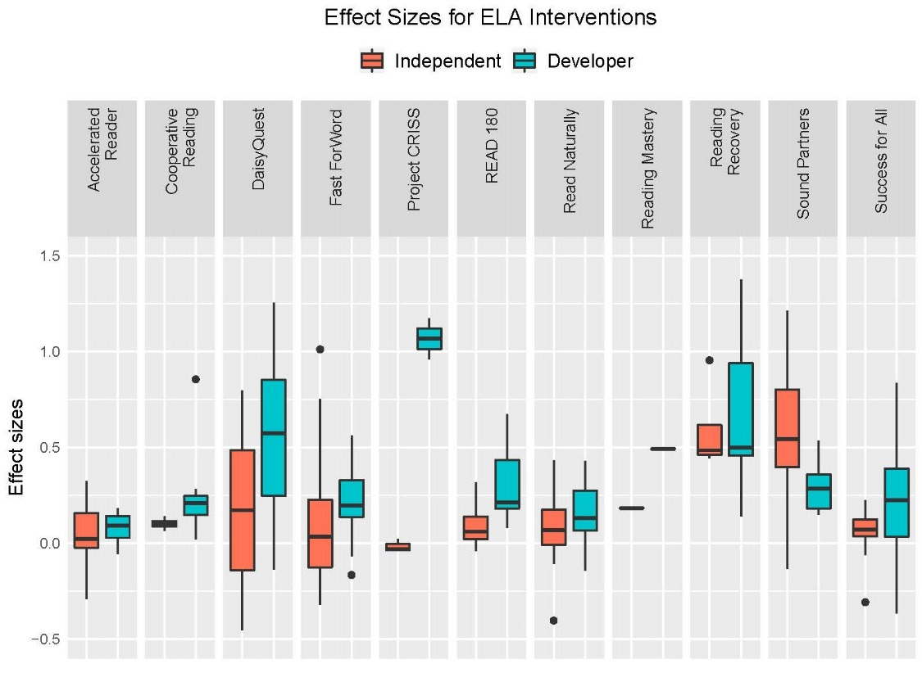
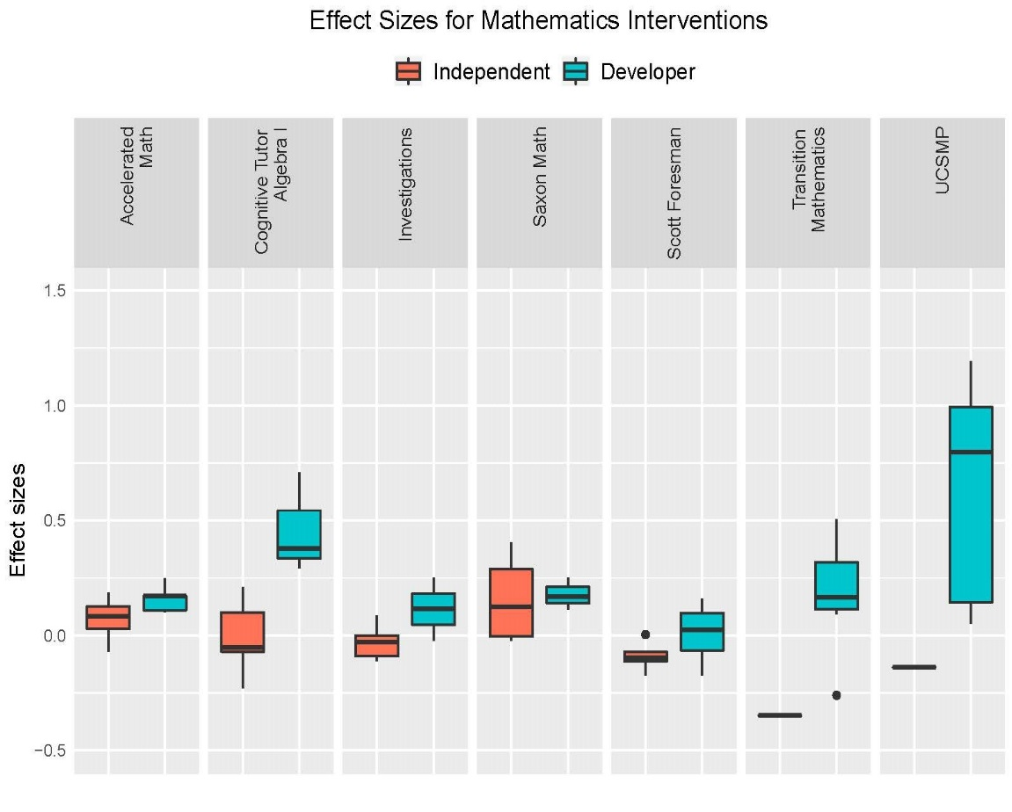
Controlling for observed study and program characteristics, the average effect size for independent studies was +0.194, and the average effect size for developer-commissioned studies was +0.324 for the same interventions, a difference of 0.130. In other words, when looking within the same program, developer-commissioned studies produced average effect sizes that were 1.7 times greater than those in independent studies. These meta-analysis regression results are presented in Table 2.
Table 2: Meta-Regression Results

 | Estimate | Standard error | t-statistic | Degrees of  freedom | p-value
Null Model
Intercept | 0.216 | 0.022 | 9.83 | 130 | .000
Effect size N | 755
Study N | 169
$$τ^{2}$$ | .017
$$ω^{2}$$ | .110
Subsample Model with Covariates + Intervention Dummy Variables
Intercept | 0.194 | 0.036 | 5.452 | 28 | .000
Developer | 0.130 | 0.050 | 2.589 | 26 | .016
Finding N | 350
Study N | 91
$$τ^{2}$$ | .000
$$ω^{2}$$ | .046
Full Sample Model with Covariates
Intercept | 0.168 | 0.029 | 5.767 | 65 | .000
Developer | 0.141 | 0.039 | 3.671 | 68 | .000
Finding N | 755
Study N | 169
$$τ^{2}$$ | .000
$$ω^{2}$$ | .100
Notes. 1. The null model was based on the full sample of WWC studies. 2. The subsample model with covariates and intervention dummy variables controlled for quasi-experimental design, outcome measure type, grade level band, publication date, educational technology, and delivery method, in addition to a dummy variable for each intervention. 3. The full sample model with covariates controlled for quasi-experimental design, outcome measure type, grade level band, program type, delivery method, educational technology, academic subject, publication date, and interactions between outcome measure type and educational technology, program type and educational technology, elementary and program type, and elementary and delivery method.

While developer-commissioned studies produced larger effect sizes than independent studies, on average, there was considerable heterogeneity in the effect sizes in both groups. The 95% prediction interval for the effect sizes in independent studies was (-0.227, +0.615), and (-0.097, +0.745) in developer studies, when controlling for study and program characteristics. Figure 3 shows the distribution of the empirical Bayes predictions of the effect sizes in independent and developer studies of the same interventions, using the model that included all of the covariates. Even when accounting for very imprecise estimates and controlling for study and program characteristics, the distributions show higher effect sizes in developer studies than in independent ones.
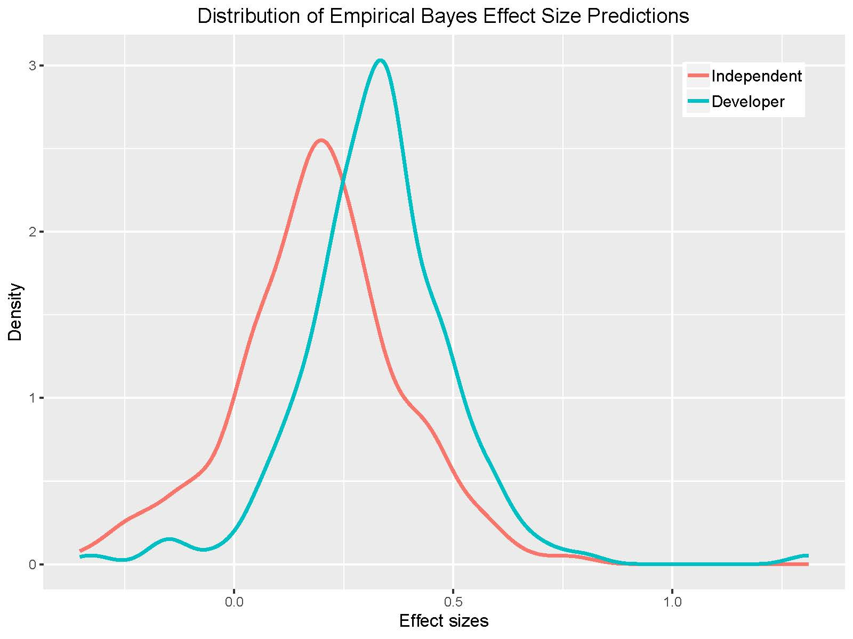
Examining the average effect size for developer versus independent studies in the full sample of WWC studies produced similar results. Controlling for study and program characteristics, the average effect size for independent studies was +0.168, as compared with +0.309 for developer studies, a difference of 0.141. Put simply, developer-commissioned studies in the WWC had an average effect size that was 1.8 times larger than the average effect size in independent studies, even when accounting for observed study and program characteristics. As in the previous findings, we found substantial heterogeneity in effect sizes in the full sample of WWC studies. The 95% prediction interval for independent studies was (-0.452, +0.788) and (-0.311, +0.929) for developer ones, controlling for study and program characteristics.
We conducted a number of sensitivity analyses to determine if a developer effect persisted with various subsamples of the data. We removed studies conducted by graduate students from the sample. We conducted the analysis for studies with experimental designs only, and then for studies with quasi-experimental designs only. In these cases, the developer effect persisted and was similar in magnitude to our previous findings.
While we cannot definitively determine why a developer effect may exist, we explore a couple of possibilities. First, it is possible that authors of developer studies were more likely than the authors of independent studies to selectively report the largest effect sizes. Negative effect sizes comprised 20% of the effects in independent studies versus 14% of the effects in developer studies. Effect sizes between 0.00 and 0.20 comprised 31% of the effects in independent studies versus 25% in developer studies. And effect sizes greater than 0.20 comprised 49% of the effects in independent studies versus 61% of the effects in developer studies. While we cannot prove that selective reporting occurred, it is one plausible explanation for the developer effect.
Second, we explored whether a developer effect may exist due to publication bias, where developers withhold or incentivize third-party researchers to withhold unimpressive studies or even findings within a study, and do so to a greater extent that researchers in independent studies. For all studies included in the WWC database and for developer studies only, there was not a statistically significant difference in the study-level average effect sizes adjusted for publication bias with the Vevea and Hedges correction. For independent studies only, there was a statistically significant difference in the effect sizes adjusted for publication bias, but in the reverse direction.
The average study-level effect size for developer studies was +0.292, and when adjusting for publication bias, it was +0.276, as shown in Table 3. For independent studies, the average study-level effect size was +0.177 and +0.200 when adjusting for publication bias. The difference between the average study-level effect size for developer and independent studies was +0.115, and +0.076 when adjusting for publication bias. This means that approximately 66% of the difference in average effect sizes between developer and independent studies could be explained by publication bias. This finding should be interpreted with caution, however, since the Vevea and Hedges correction uses study-average effect sizes as opposed to individual effect sizes. In addition, the adjusted effect sizes were not statistically significantly different from the unadjusted ones for developer studies. Still, we conclude that publication bias likely contributes to the developer effect, although it is likely not the only driver.

Table 3: Potential for Publication Bias
 | Study-average effect size | With Vevea-Hedges correction
All studies | 0.233 | 0.241
Developer studies | 0.292 | 0.276
Independent studies | 0.177 | 0.200*
Note. *$p$<.05 indicates statistical significance from the likelihood ratio test that indicates whether the model that adjusted for publication bias was a better fit for the data.

Selective reporting of outcomes and publication bias are only two of the many plausible explanations for the existence of a developer effect. We discuss other plausible explanations for the developer effect, as well as limitations of this study, in the following section.
Discussion
This study used What Works Clearinghouse (WWC) study data to explore whether effect sizes in developer-commissioned studies were systematically larger than those in independent studies. Using meta-analytic techniques and controlling for observed study and program characteristics, we found an average effect size of +0.309 for developer-commissioned studies and +0.168 for independent studies, a difference of 0.141 standard deviations. Even when comparing effect sizes for developer and independent studies for the same interventions, we found that effect sizes were larger in developer-commissioned studies by +0.130, on average. The “developer effect” was largely unexplained by observed study and program characteristics available in the WWC data.
These findings beg the question of whether we should trust results from studies either authored or funded by program developers to the same extent we trust results from independent studies. While this study is descriptive in nature, it provides evidence that funding source and authorship may be important considerations in interpreting the knowledge base on what works in education.
We cannot conclusively determine the source of this “developer effect.” We offer several plausible explanations for the existence of the developer effect, yet more research on this topic is warranted. First, descriptive evidence suggests that developer studies may selectively report only the most promising outcomes to a greater extent than independent studies. Negative or small effect sizes may be more likely to go unreported in developer studies compared with independent ones. Second, we found that publication bias may explain up to 66% of the developer effect. We are less confident, however, as to this exact percentage, and whether this finding would generalize to other data sources as independent studies with null findings may be more likely to be included in the WWC study data than other data sources due to federal reporting requirements.
Third, researcher degrees of freedom may be a contributing factor to the developer effect. While the WWC standards outline requirements in terms of data elements that must be reported and analytic approaches that may be used, there is still ample room for researchers to make analytical choices to optimize a study’s outcomes. It is unclear, however, to what extent developers would abuse these degrees of freedom more than independent researchers, who may also desire to optimize outcomes to produce publishable findings (John et al., 2012).
Fourth, differences in the control conditions between developer and independent studies could theoretically account for the developer effect. A brief description of the control condition is provided in the WWC data, and the control condition was “business-as-usual” (as opposed to another program) in 80% of independent studies and 86% of developer studies. Thus, while it does not appear at first glance that differences in the control conditions were the main driver of the developer effect, it is plausible that there may be other differences about the control conditions between developer and independent studies.
Finally, the developer effect may be attributable to differences in treatment fidelity between developer and independent studies, if developers worked to ensure high levels of implementation in studies they commissioned. Data on treatment fidelity are not currently available in the WWC study data, and a limitation of this study is that we could not explore this hypothesis.
A potential solution to mitigate any bias resulting from selective reporting of the best outcomes, publication bias, and researcher degrees of freedom would be to require program evaluations (including specific outcome measures and analyses) to be preregistered in order for them to be included in the WWC or other program review facilities. Preregistration could include describing the study design, outcome measures, and analyses to be conducted, and the WWC or other reviews could accept only the pre-specified outcome measures and analyses. If measures or analyses promised in preregistration are not included in the final report, and no valid rationale is provided, the study and its findings could be flagged as not meeting the requirements of the preregistry. Evaluators could do other analyses or use additional measures, for example to learn more about the treatments or to contribute to theory, but these outcomes would not qualify for inclusion in the WWC or other reviews. Preregistration could also include providing descriptions of the counterfactual conditions and the fidelity of implementation. Although these topics are arguably more subjective than providing a statistical model, richer descriptions of both the counterfactual and implementation fidelity would allow researchers to investigate and perhaps to better understand the heterogeneity in treatment effects.
Preregistration is now being used in the field of education. In 2018, the Institute for Education Sciences launched the Registry of Efficacy and Effectiveness Studies (REES) (see https://sreereg.org) (Anderson, Spybrook, & Maynard, 2018). The underlying goal of REES is to mitigate “questionable research practices” and increase our confidence in the knowledge base (Anderson, Spybrook, & Maynard, 2018, p. 45). REES was designed specifically for program evaluations in education, or studies that “seek to determine the efficacy or effectiveness of an educational intervention or strategy” (Anderson, Spybrook, & Maynard, 2018, p. 48). Preregistration is undoubtedly a positive advancement in our field (Gehlbach & Robinson, 2018).
We do not expect preregistration to eliminate all bias, however. With any preregistration that is likely to be used by researchers, some researcher degrees of freedom will remain. Gelman and Loken (2014) remarked that researchers can learn a lot by “looking at the data” (p. 464). Moreover, interventions implemented in district and school environments do not always go according to plan, requiring adjustments to evaluation plans (Gelman & Loken, 2014). We therefore advocate for researchers to also publish their study data along with the study results, whenever possible, so that other researchers can re-analyze the data and attempt to replicate the study findings. Open access to study data holds the greatest promise for mitigating bias when authors publish complete datasets, including missing values and all participants who were included in the study at the onset, to the extent possible.
We also encourage educational researchers and policymakers to pay more attention to contextual factors that may influence effect sizes, such as who conducted or paid for the evaluation. As educational researchers, we are both gatekeepers of what constitutes rigorous evidence as well as translators to practitioners about the strength of the evidence base. If our goal as educational researchers is to provide the education community with trusted sources of evidence, understanding potential sources of bias in education program evaluations and attempting to correct them is critical in moving towards educational decision-making based on rigorous evidence.

References
Anderson, D., Spybrook, J., & Maynard, R. (2019). REES: A registry of efficacy and effectiveness studies in education. Educational Researcher, 48(1), 45-50.
Baye, A., Lake, C., Inns, A., & Slavin, R. (2018). A synthesis of quantitative research on reading programs for secondary students. Reading Research Quarterly.
Bloom, H., Michalopoulos, C., Hill, C., & Lei, Y. (2002). Can nonexperimental comparison group methods match the findings from a random assignment evaluation of mandatory welfare-to-work programs? New York: MDRC Working Papers on Research Methodology.
Carroll, C., Patterson, M., Wood, S., Booth, A., Rick, J., & Balain, S. (2007). A conceptual framework for implementation fidelity. Implementation Science, 2(1), 40.
Cheung, A., & Slavin, R. (2016). How methodological features affect effect sizes in education. Educational Researcher, 45(5), 283– 292. https://doi.org/10.3102/0013189X16656615
Coburn, K., & Vevea, J. (2019). weightr: Estimating Weight-Function Models for Publication Bias. R package version 2.0.2. Retrieved from https://CRAN.R-project.org/package=weightr
Cook, T. (2002). Randomized experiments in educational policy research: A critical examination of the reasons the educational evaluation community has offered for not doing them. Educational Evaluation and Policy Analysis, 24(3), 175-199.
de Boer, H., Donker, A., & van der Werf, M. (2014). Effects of the attributes of educational interventions on students’ academic performance: A meta-analysis. Review of Educational Research, 84(4), 509-545.
Dietrichson, J., Bǿg, M., Filges, T., & Jorgensen, A. K. (2017). Academic interventions for elementary and middle school students with low socioeconomic status: A systematic review and meta-analysis. Review of Educational Research 87(2), 243-282.
Fryer Jr, R. (2017). The production of human capital in developed countries: Evidence from 196 randomized field experiments. In Handbook of economic field experiments (Vol. 2, pp. 95-322). North-Holland.
Gehlbach, H., & Robinson, C. (2018). Mitigating illusory results through preregistration in education. Journal of Research on Educational Effectiveness, 11(2), 296-315.
Gelman, A., & Loken, E. (2014). The statistical crisis in science. American Scientist, 102(6), 460-465.
Gersten, R., Chard, D., Jayanthi, M., Baker, S., Morphy, P., & Flojo, J. (2009). Mathematics instruction for students with learning disabilities: A meta-analysis of instructional components. Review of Educational Research, 79(3), 1202-1242.
Hedges, L. (2007). Effect sizes in cluster-randomized designs. Journal of Educational and Behavioral Statistics, 32, 341–370.
Hedges, L., Tipton, E., & Johnson, M. (2010). Robust variance estimation in meta‐regression with dependent effect size estimates. Research Synthesis Methods, 1(1), 39-65.
Hill, C. J., Bloom, H. S., Black, A. R., & Lipsey, M. W. (2008). Empirical benchmarks for interpreting effect sizes in research. Child Development Perspectives, 2(3), 172-177.
John, L., Loewenstein, G., & Prelec, D. (2012). Measuring the prevalence of questionable research practices with incentives for truth telling. Psychological Science, 23(5), 524-532.
Klein, A. (2018, April 3). Satisfying ESSA's evidence-based requirements proves tricky. Education Week, 37 (5), 9-11.
Kulik, J., & Fletcher, J. (2016). Effectiveness of intelligent tutoring systems: A meta-analytic review. Review of Educational Research, 86(1), 42-78.
Lester, P. (2018). Evidence-based comprehensive school improvement. Retrieved from http://socialinnovationcenter.org/wp-content/uploads/2018/03/CSI-turnarounds.pdf.
Lexchin, J. (2012). Sponsorship bias in clinical research. International Journal of Risk & Safety in Medicine, 24(4), 233-242.
Lexchin, J., Bero, L. A., Djulbegovic, B., & Clark, O. (2003). Pharmaceutical industry sponsorship and research outcome and quality: Systematic review. Bmj, 326(7400), 1167-1170.
Li, Q., & Ma, X. (2010). A meta-analysis of the effects of computer technology on school students’ mathematics learning. Educational Psychology Review, 22(3), 215-243.
Lipsey, M. W., Puzio, K., Yun, C., Hebert, M. A., Steinka-Fry, K., Cole, M. W., ... & Busick, M. D. (2012). Translating the statistical representation of the effects of education interventions into more readily interpretable forms. National Center for Special Education Research.
Lipsey, M., & Wilson, D. (2001). Practical meta-analysis. Thousand Oaks, CA: Sage Publications.
Lundh, A., Lexchin, J., Mintzes, B., Schroll, J. B., & Bero, L. (2017). Industry sponsorship and research outcome. Cochrane Database of Systematic Reviews, (2).
Meta-Analysis Training Institute (2019). Chicago, IL. https://www.meta-analysis-training-institute.com/
McBee, M., Makel, M., Peters, S., & Matthews, M. (2017). A manifesto for open science in giftedness research. Retrieved from osf.io/qhwg3
Munter, C., Cobb, P., & Shekell, C. (2016). The role of program theory in evaluation research: A consideration of the What Works Clearinghouse standards in the case of mathematics education. American Journal of Evaluation, 37(1), 7-26.
Olkin, I., & Gleser, L. (2009). Stochastically dependent effect sizes. The handbook of research synthesis and meta-analysis, 357-376.
Pellegrini, M., Inns, A., Lake, C., & Slavin, R. (2019, March). Effects of researcher-made versus independent measures on outcomes of experiments in education. Paper presented at the annual meeting of the Society for Research on Educational Effectiveness. Washington, DC.
Pinquart, M. (2016). Associations of parenting styles and dimensions with academic achievement in children and adolescents: A meta-analysis. Educational Psychology Review, 28(3), 475-493.
Polanin, J., Tanner-Smith, E., & Hennessy, E. (2016). Estimating the difference between published and unpublished effect sizes: A meta-review. Review of Educational Research, 86(1), 207-236.
Pustejovsky, J. (2019). clubSandwich: Cluster-Robust (Sandwich) Variance Estimators with Small-Sample Corrections. R package version 0.3.5. Retrieved from https://CRAN.R-project.org/package=clubSandwich
R Core Team (2018). R: A language and environment for statistical computing. R Foundation for Statistical Computing, Vienna, Austria. URL https://www.R-project.org/.
Simmons, J., Nelson, L., & Simonsohn, U. (2011). False-positive psychology: Undisclosed flexibility in data collection and analysis allows presenting anything as significant. Psychological Science, 22(11), 1359-1366.
Slavin, R. (2013). Effective programmes in reading and mathematics: lessons from the Best Evidence Encyclopaedia. School Effectiveness and School Improvement, 24(4), 383-391.
Slavin, R., & Lake, C. (2008). Effective programs in elementary mathematics: A best-evidence synthesis. Review of Education Research, 78(3), 427-515.
Slavin, R., Lake, C., & Groff, C. (2009). Effective programs in middle and high school mathematics: A best-evidence synthesis. Review of Educational Research 79(2), 839-911.
Slavin, R., & Smith, D. (2009). The relationship between sample sizes and effect sizes in systematic reviews in education. Educational Evaluation and Policy Analysis, 31(4), 500-506.
Sterling, T., Rosenbaum, W., & Weinkam, J. (1995). Publication decisions revisited: The effect of the outcome of statistical tests on the decision to publish and vice versa. The American Statistician, 49(1), 108-112.
Tipton, E. (2015). Small sample adjustments for robust variance estimation with meta-regression. Psychological Methods, 20(3), 375.
Vevea, J. L. & Hedges, L. V. (1995). A general linear model for estimating effect size in the presence of publication bias. Psychometrika, 60(3), 419-435.
Viechtbauer, W. (2010). Conducting meta-analyses in R with the metafor package. Journal of Statistical Software, 36(3), 1-48. Retrieved from http://www.jstatsoft.org/v36/i03/
What Works Clearinghouse. (2017a). What Works Clearinghouse Standards Handbook Version 4.0. Institute of Education Sciences, U. S. Department of Education. Retrieved from https://ies.ed.gov/ncee/wwc/Docs/referenceresources/wwc_standards_handbook_v4.pdf
What Works Clearinghouse. (2017b). What Works Clearinghouse Procedures Handbook Version 4.0. Institute of Education Sciences, U. S. Department of Education. Retrieved from https://ies.ed.gov/ncee/wwc/Docs/referenceresources/wwc_procedures_handbook_v4.pdf
Wickham, H. (2016). ggplot2: Elegant Graphics for Data Analysis. Springer-Verlag, New York.
Wilson, D., Gottfredson, D., & Najaka, S. (2001). School-based prevention of problem behaviors: A meta-analysis. Journal of Quantitative Criminology, 17(3), 247-272.
Wilson, D., & Lipsey, M. (2001). The role of method in treatment effectiveness research: Evidence from meta-analysis. Psychological Methods, 6(4), 413.

The WWC data were extracted in January of 2018. These data included studies in the elementary school math, middle school math, high school math, primary math, secondary math, beginning reading, foundational reading, reading comprehension, and adolescent literacy protocols.
Twenty studies had at least one finding that was missing an effect size; the effect sizes could not be calculated for these findings, according to the WWC reviewers. These 142 findings were dropped from the sample. An additional study was eliminated from the sample because the outcome was a pass rate, and all other outcomes in the database were test scores.
In some cases, these data fields were missing from the WWC database when downloading all studies at one time. However, most of the missing data fields could be obtained by searching for each study individually on the WWC website and downloading the individual study’s details. In very few cases did we have to review the original study to populate the missing data fields. The exception was the ICC: the ICC was rarely populated, and we assumed 0.20 in all missing cases (following WWC protocol).
We used the WWC classifications but in cleaning the data, we noticed some discrepancies in program type and delivery method for the same program. While it is possible that the same intervention had different delivery methods across studies, we cross-referenced inconsistent codings that appeared to be inaccurate against the intervention’s webpage on the WWC website. For ease of interpretation, we also restricted each intervention to one program type and one delivery method, and if multiple program types or delivery methods were marked for one intervention, we defaulted to the most comprehensive selections.
In cases where the source of funding for the study was unclear, we emailed the authors to inquire about the source of funding for the study.
Examples included STAR Assessments with Accelerated Reading or Math interventions, University of Chicago School Mathematics Project (UCSMP) assessments with the UCSMP intervention, Comprehension Reading Assessment Battery (CRAB) and Spheres of Proud Achievement in Reading for Kids (SPARK) with the Peer-Assisted Learning Strategies (PALS) intervention, Observation Survey with the Reading Recovery intervention, and Core-Plus assessments with the Core-Plus Mathematics Project intervention.
In this article, the use of “cluster” is reserved for the studies that assigned treatment at the cluster level.
The following code was used to estimate the multivariate meta-regression model (Meta-Analysis Training Institute, 2019): # Specify the observed covariance matrix: data=name of dataset, vij=observed effect-size-level variances, # .80=assumed correlation among effect sizes within studies matrix_name <- impute_covariance_matrix(vi = data$vij, cluster = data$studyid, r = .80) # Run the model: effect_size=variable containing finding-level effect sizes, mods=moderator variables model_name <- rma.mv(yi=effect_size, V = matrix_name, mods = ~ covarate1 + covariate2 + …, random = ~1 | studyid/findingid, test= "t", data=data, method="REML") # Produce RVE estimates robust to model misspecification: “CR2”=estimation method rve_based <- coef_test(model_name, cluster=data$studyid, vcov = "CR2")

